Thursday, 08 January 2026
Chinese New Year Show / Celebrations Art Competition
Dear Parents and Carers,
Some exciting news! We are giving pupils a chance to be part of the celebrations through the Chinese New Year Art competition. Pupils are asked to create an A4 sized picture for the Chinese Year of the Horse 2026. The Year of the Horse symbolises freedom, energy, movement, and ambition, representing a time for action, progress, and breaking old patterns, with people born in this year often seen as independent, hardworking, and sociable. It signifies vitality, courage, and a spirit of adventure, encouraging bold steps, new journeys, and fostering strong connections, with the upcoming 2026 being a Fire Horse year, adding extra dynamism and passion.
The pupils who submit the winning entries will receive a pair of tickets for the exhibition launch party. The Chinese New Year Show at the University campus, being held on 12th March 2026, where the winning artwork will be exhibited between 13-20th March at the Diamond building. Pupils will also have the opportunity to win prizes, including gift vouchers, for their art entries.
If you wish to enter the competition, please submit your artwork to the office by Friday 13th February 2026. If you are successful, your parent will be contacted with regards to receiving your tickets.
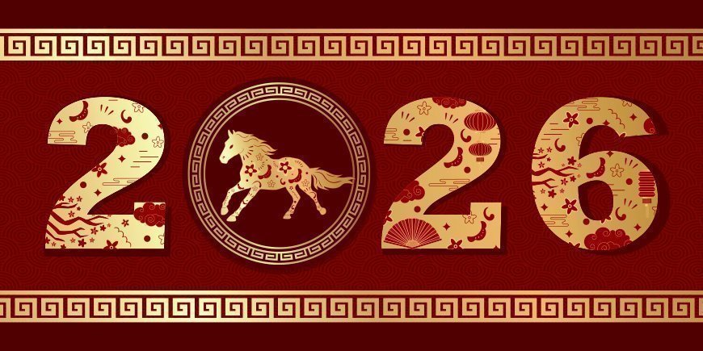
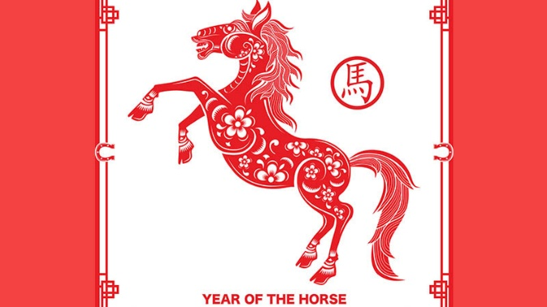
I am looking forward to seeing your fantastic drawings or paintings.
Good luck
Miss Woffindin

