Friday 24th February 2023

Dear Parent/carer,
6 steps to well-being
I am writing to inform you that the next step on our ‘6 steps to well-being’ project is ‘Mindfulness’. We will be working with the children throughout this half term to highlight the importance of being mindful and the benefits this can have on their mental health and well-being. Research shows that practising mindfulness (paying attention to what is happening in the present moment) can help you to build confidence, manage stress and cope in difficult and challenging situations.
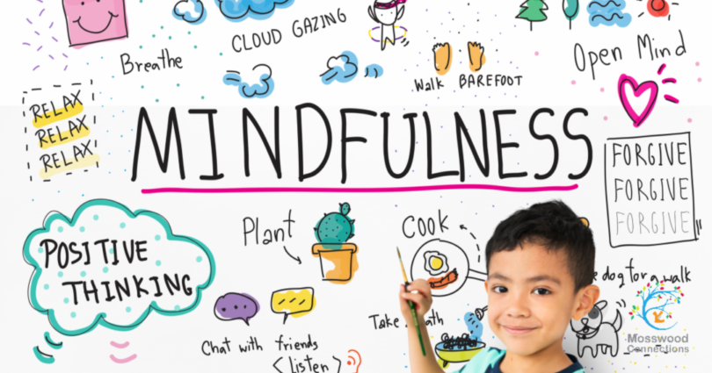
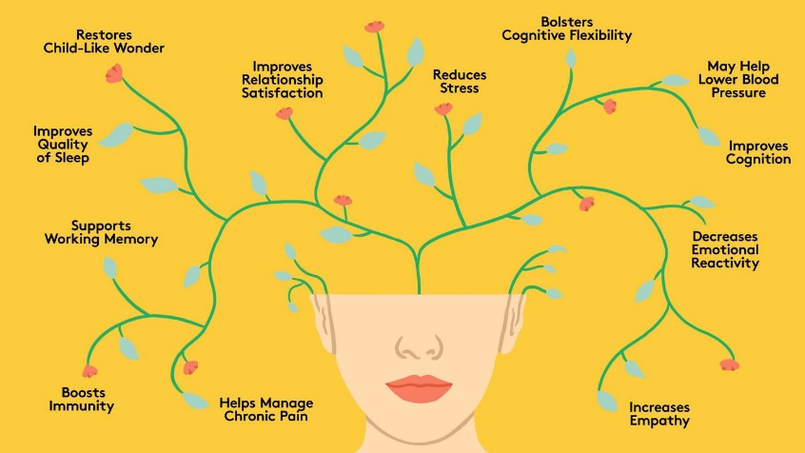

We would like everybody to be involved in this; therefore, we are asking you as parents and carers to get involved. We challenge you to try some mindfulness activities/practises with your family; there are some ideas and suggestions on the flyer overleaf. We would love to hear about your mindful activities, so please hand in your photos/evidence to the office or let a member of staff know about what you have done so that your child can be entered into a prize draw to win a treat for the family.
We now have a ‘6 steps to well-being’ page on our website https://portercroft.org/6-steps-to-wellbeing/, which contains all of the information and strategies/ideas you need to promote the ‘6 steps to well-being’ at home.

Thank you all for your continued support,
Rebecca Hocking
(Inclusion Leader)

Mindful activity ideas:
- Go on a walk in the countryside/local area
- Blowing bubbles
- Watching the clouds (finding shapes in the clouds)
- Breathing exercises https://www.moshikids.com/articles/deep-breathing-exercises-for-kids/
- Mindfulness colouring
- Tasting new foods
- Doodling
- Nature trail (looking for wildlife)
- Relaxing and tensing
- Focus on the 5 senses: What can you hear? What can you see? What can you taste? What can you smell? What can you feel?
- Thinking about what you are thankful for
- Listen to music

Useful websites:
- BBC Mood Boosters - https://www.bbc.co.uk/teach/moodboosters
- Mindfulness Hub - https://www.bbcchildreninneed.co.uk/schools/primary-school/mindfulness-hub/
- Cosmic Kids YouTube videos - https://www.youtube.com/watch?v=wf5K3pP2IUQ

